Retail Sales & Returns Analytics using SQL Server

An End-to-End SQL Analytics Project for Business Intelligence and Decision Support

Prepared by
Sahil Pawar
Aspiring Data Analyst

Project Overview

This project was developed to simulate a real-world retail analytics scenario using Microsoft SQL Server. The primary objective was to transform raw transactional sales and return data into a structured analytical reporting layer capable of supporting business intelligence and decision-making. Instead of focusing only on SQL syntax, the project emphasized solving real business problems by designing reusable SQL views, defining meaningful KPIs, and answering critical business questions across sales performance and return analysis.
During the project, reusable analytical views were created to evaluate product performance, category performance, customer performance, product returns, category returns, and return reasons. Business KPIs such as revenue, profit, quantity sold, return rate, and ranking metrics were developed to provide meaningful insights into overall business performance. The final reporting layer was specifically designed to serve as a backend data source for future Power BI dashboards, creating an end-to-end business intelligence solution.

Business Problem
The retail company aims to better understand its sales performance and product return behavior to improve profitability, identify high-performing products, categories, and customers, and reduce product returns through data-driven decision-making.

3. Project Objectives
The primary objectives of this project were to:
- Analyze retail sales performance across products, categories, and customers.
- Evaluate customer purchasing behavior through transactional sales analysis.
- Measure product and category revenue, profitability, and sales performance using business KPIs.
- Analyze product return behavior and identify the primary reasons contributing to returns.
- Design reusable SQL views to support scalable reporting and business analysis.
- Develop a structured reporting layer for seamless integration with Power BI dashboards.

5. Technology Stack

Category | Technology
Database | Microsoft SQL Server
Language | T-SQL
IDE | SQL Server Management Studio
Visualization | Power BI (Planned)

6. Dataset Overview

The project utilizes a retail transactional database consisting of six interconnected tables that capture customer information, product catalog details, sales transactions, and product return records. Together, these tables provide the foundation for analyzing sales performance, customer purchasing behavior, profitability, and return trends.

Table | Description | Primary Key
Customers | Stores customer information such as customer ID, name, contact details, and location. | customer_id
orders | Contains order-level information including customer, order date, and order status. | order_id
order_items | Stores individual products purchased within each order, including quantity and transaction price. | order_item_id
Products | Product master table containing selling price, cost price, and category information. | product_id
Categories | Defines product categories used for sales and return analysis. | category_id
returns | Records returned products along with return dates and return reasons. | return_id

Dataset Relationships
The dataset follows a relational database structure where customers place orders, each order consists of one or more order items, order items reference products, products belong to categories, and returned products are recorded in the returns table. These relationships enable comprehensive sales and return analysis across multiple business dimensions.

7. Data Model
The retail database follows a relational data model where customer transactions are recorded across multiple interconnected tables. These relationships enable the analysis of sales performance, customer purchasing behavior, product profitability, and product returns. The data model serves as the foundation for building reusable analytical SQL views and business KPIs.

Customers
│
▼
Orders
│
▼
Order Items
├────────► Products ───────► Categories
│
▼
Returns

Figure 1. Retail Data Model
The data flows from customers placing orders to individual products being purchased. Products are grouped into categories, while returned items are tracked separately through the returns table. This relational structure forms the foundation for all sales, customer, category, and return analyses performed in this project.

8. Business Questions
The project was designed to answer key business questions related to sales performance, customer behavior, profitability, and product returns. These questions guided the development of the SQL views and business KPIs throughout the project.

Sales Performance Analysis

Product Performance
- Which products generate the highest revenue?
- Which products generate the highest profit?
- Which products have the highest sales volume?

Category Performance
- Which product categories generate the highest revenue?
- Which product categories generate the highest profit?
- Which categories sell the highest quantity of products?

Customer Performance
- Which customers generate the highest revenue?
- Which customers generate the highest profit?
- Which customers purchase the highest quantity of products?

Return Analysis

Product Returns
- Which products are returned most frequently?
- Which products have the highest return rate?

Category Returns
- Which categories experience the highest number of returns?
- Which categories have the highest return rate?

Return Reasons
- What are the most common reasons for product returns?
- What percentage of total returns does each return reason contribute?

9. SQL Views & KPIs
Introduction
To support business reporting and simplify future dashboard development, a series of reusable SQL views were created. Each view focuses on a specific business area and provides pre-calculated KPIs that can be directly consumed by reporting tools such as Power BI.

9.1 vw_product_performance
Purpose
Evaluates the sales performance of individual products by calculating key business metrics and ranking products based on revenue and profitability.
KPIs
- Total Quantity Sold
- Total Revenue
- Total Profit
- Revenue Rank
- Profit Rank
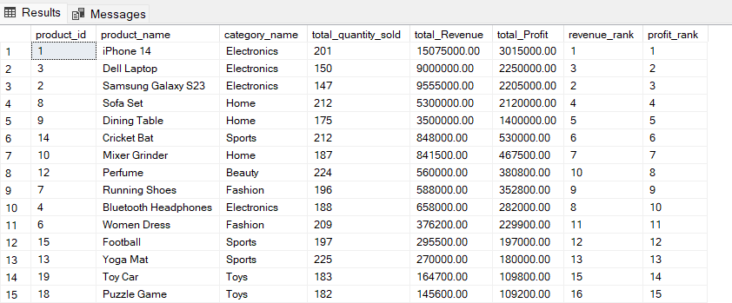

9.2 vw_category_performance
Purpose
Aggregates product-level data to evaluate overall category performance and compare categories using business KPIs.
KPIs
- Total Quantity Sold
- Total Revenue
- Total Profit
- Revenue Rank
- Profit Rank
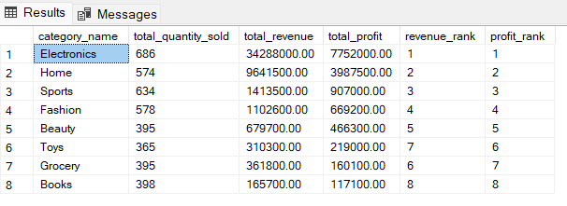

9.3 vw_customer_performance
Purpose
Analyzes customer purchasing behavior by measuring order activity, purchasing volume, revenue contribution, and profitability.
KPIs
- Total Orders
- Total Quantity Purchased
- Total Revenue
- Total Profit
- Revenue Rank
- Profit Rank11
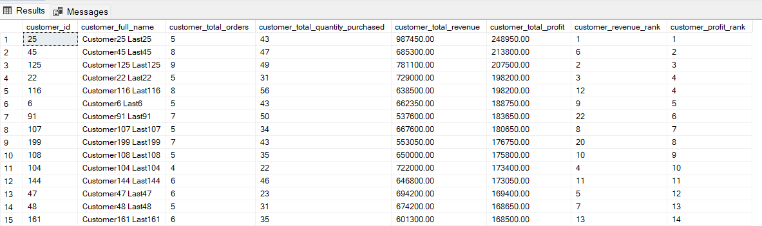

9.4 vw_return_details
Purpose
Serves as the base analytical view for all return-related analysis by combining customer, order, product, category, and return information into a single reporting dataset.
Contains
- Customer Information
- Product Information
- Category Information
- Return Date
- Return Reason
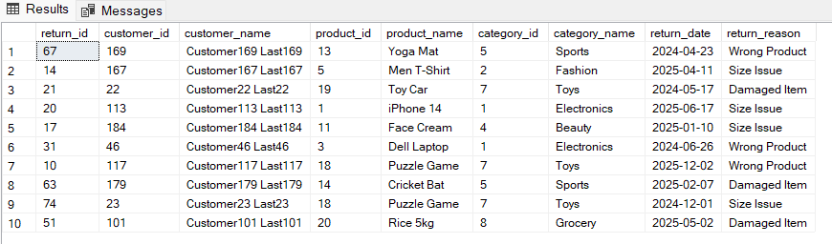

9.5 vw_product_return_analysis
Purpose
Measures product return performance by calculating the number of returns, return rate, and ranking products based on return frequency.
KPIs
- Total Returns
- Return Rate
- Return Rank
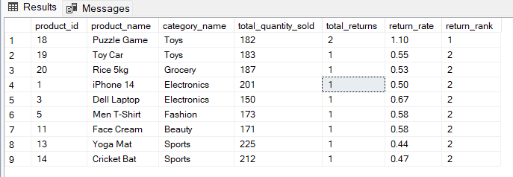

9.6 vw_category_return_analysis
Purpose
Summarizes return performance at the category level to identify categories with the highest return volume and return rate.
KPIs
- Total Returns
- Return Rate
- Return Rank
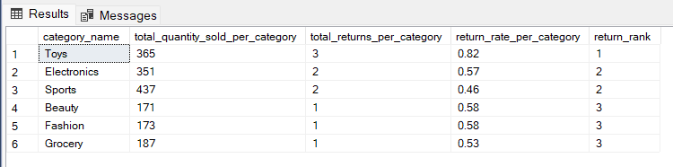

9.7 vw_return_reason_analysis
Purpose
Analyzes the distribution of return reasons to understand the primary factors contributing to product returns.
KPIs
- Total Returns
- Return Percentage
- Return Rank
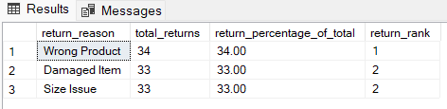

10. Business Insights

The analytical views developed throughout this project were used to derive meaningful business insights related to sales performance, customer behavior, profitability, and product returns. These findings can support strategic decision-making aimed at improving revenue, profitability, and customer satisfaction.

Sales Performance Insights

Product Performance
- Identified the highest-performing products based on total revenue and total profit.
- Ranked products using revenue and profit KPIs to support product-level performance evaluation.
- Measured product sales volume using total quantity sold.

Category Performance
- Evaluated category performance using revenue, profit, and quantity sold.
- Identified top-performing categories based on overall business contribution.
- Enabled category-level comparisons through reusable ranking metrics.

Customer Performance
- Identified the highest-value customers based on revenue generation and profitability.
- Measured customer purchasing behavior through total orders and total quantity purchased.
- Ranked customers to support customer segmentation and future loyalty initiatives.

Return Analysis Insights

Product Returns
- Calculated return rates using returned quantity relative to total quantity sold, providing a more meaningful KPI than raw return counts.
- Identified products with the highest number of returns.
- Ranked products based on return frequency to highlight potential quality or fulfillment issues.

Category Returns
- Aggregated product return data to evaluate return performance across categories.
- Calculated category-level return rates to normalize comparisons across different sales volumes.
- Identified categories with relatively higher return behavior.

Return Reasons
- Analyzed the distribution of return reasons across all returned products.
- Found that return reasons were nearly evenly distributed:
  - Wrong Product – 34%
  - Damaged Item – 33%
  - Size Issue – 33%
- The balanced distribution suggests that product returns are influenced by multiple operational factors rather than a single dominant issue.

Business Impact
This is the section that most portfolio projects don't have, but I think yours should.
The analytical reporting layer developed in this project enables business users to monitor sales performance, customer value, profitability, and return behavior through reusable SQL views. These insights can support better inventory planning, product quality monitoring, customer relationship management, and operational improvements aimed at reducing return rates and improving overall business performance.

12. Skills Demonstrated
The project demonstrates the application of technical SQL skills, business analysis techniques, and analytical thinking to solve real-world retail business problems.

Category | Skills Demonstrated
SQL | SELECT, INNER JOIN, GROUP BY, Aggregate Functions, Window Functions (DENSE_RANK), Views
Database | Relational Database Design, Data Modeling, Reporting Layer Development
Business Analysis | KPI Design, Sales Analysis, Customer Analysis, Return Analysis, Performance Ranking
Data Analytics | Revenue Analysis, Profit Analysis, Return Rate Calculation, Trend Identification, Business Insights
Problem Solving | Analytical Thinking, KPI Development, Query Optimization, Reusable SQL View Design

13. Key Learnings
This project provided valuable experience in designing analytical SQL solutions and reinforced the importance of thinking beyond query writing. Some of the key learnings include:
- Understanding the importance of data granularity (grain) before designing analytical views and KPIs.
- Designing reusable SQL views instead of writing one-time queries for each business question.
- Developing business-focused KPIs that measure revenue, profitability, customer performance, and product returns.
- Applying window functions such as DENSE_RANK() to support business ranking and performance analysis.
- Building accurate aggregated metrics, ensuring calculations such as return rates are performed at the correct level of aggregation.
- Structuring a reporting layer that can be directly integrated with business intelligence tools like Power BI.
- Approaching SQL from a business perspective, focusing on solving business problems rather than simply retrieving data.

14. Future Improvements
The current project establishes a reusable SQL reporting layer for retail analytics. Future enhancements could include:
- Develop an interactive Power BI dashboard for business users.
- Introduce time-based sales and profitability trend analysis.
- Implement customer segmentation techniques to better understand purchasing behavior.
- Expand the KPI framework by incorporating metrics such as Profit Margin, Average Order Value, and Customer Lifetime Value.
- Integrate additional business data, such as inventory and supplier information, to support more comprehensive retail analytics.

15. Final Architecture
Introduction
The project follows a layered analytical architecture that transforms raw transactional retail data into reusable SQL reporting views. These views serve as the foundation for business analysis and future Power BI dashboards, enabling efficient and scalable business intelligence reporting.
Customers
Orders
Products
Returns
Categories
│
▼
SQL Reporting Layer
(vw_product_performance)
(vw_category_performance)
(vw_customer_performance)
(vw_return_details)
│
▼
Business KPIs
Revenue
Profit
Return Rate
Rankings
│
▼
Power BI Dashboard
The layered architecture separates raw transactional data from analytical reporting, making the solution reusable, scalable, and easier to maintain. By organizing business logic into dedicated SQL views, the reporting layer provides a reliable foundation for dashboard development, business analysis, and future analytical enhancements.

